**IICT PROJECT REPORT:-**

**PROJECT TITLE:- FOODIES.COM**

**PROJECT SUBMITTED ON:- 10th FEB 2022**

**PROJECT SUBMITTED TO:-**

**MISS ARIFA MUSTAFA**

*GROUP MEMBERS:-*

1. *ABDUL FASIH (CS211161)*
2. *MUHAMMMAD ABAIDULLAH (CS211187)*
3. *ANEEQ ARIF (CS211174)*

**PROJECT DISCRIPTION:-**

**We made an online food delivery website known as “Foodies.com” using basic HTML, CSS & JAVASCRIPT logics.**

**Customers can select and place their orders by just entering their location rather than login in using gmail, facebook or any other account.**

**All kinds of Western and Pakistani foods are available over this website.**

**Overview of the website:-**

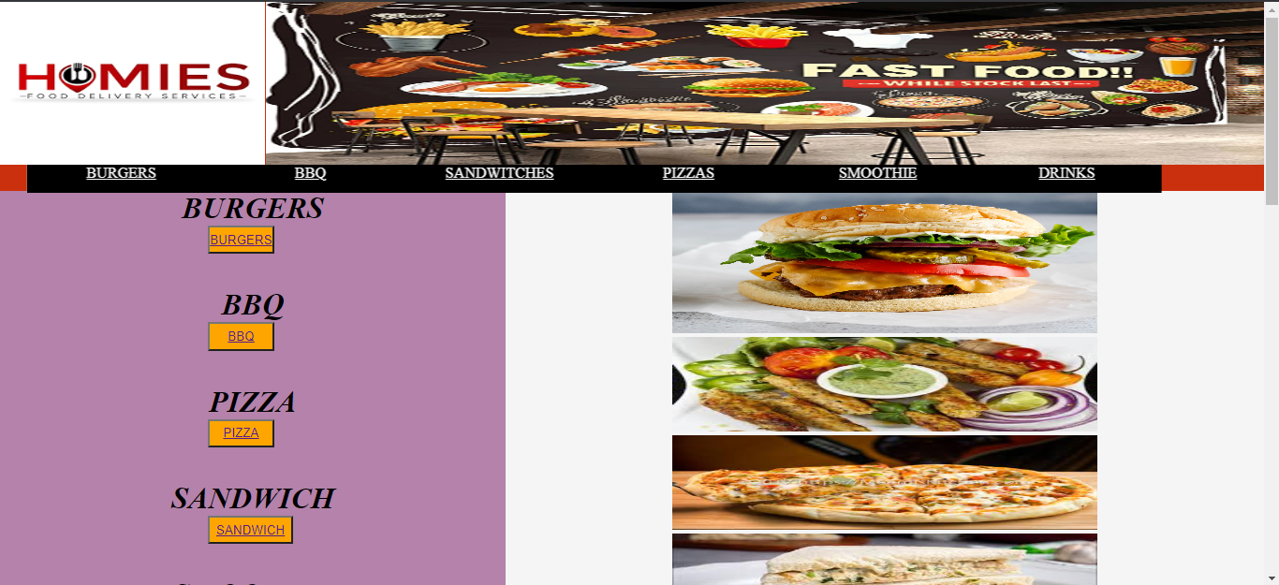

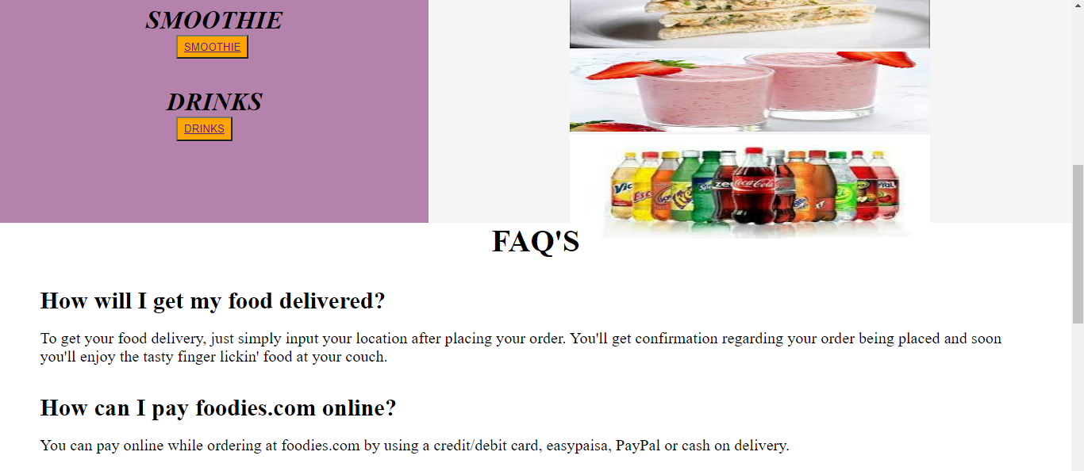

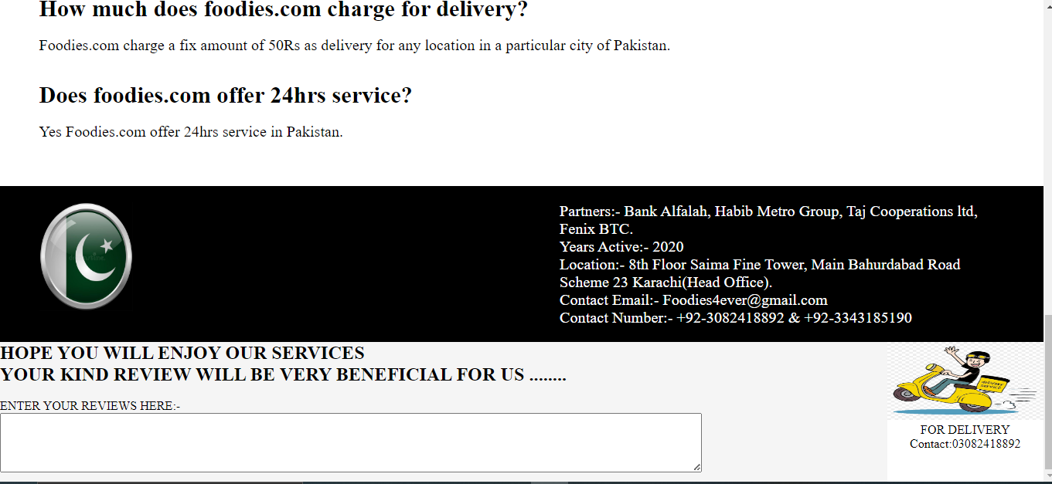

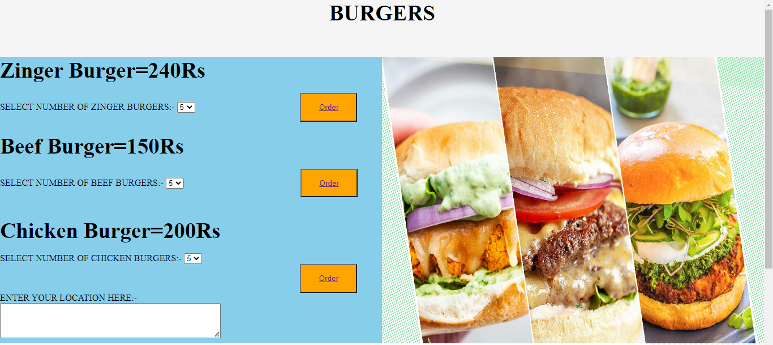

**A LOOK OVER HTML CODING:-**

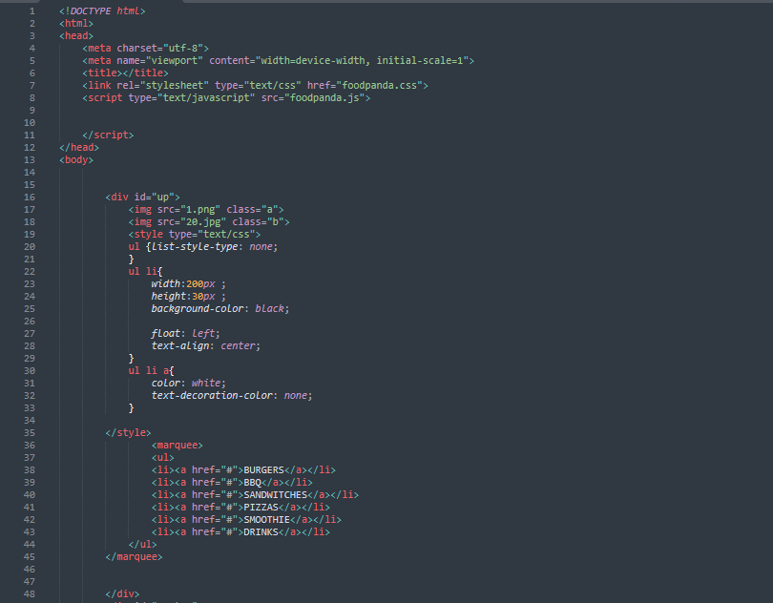

**A LOOK OVER CSS CODING:-**

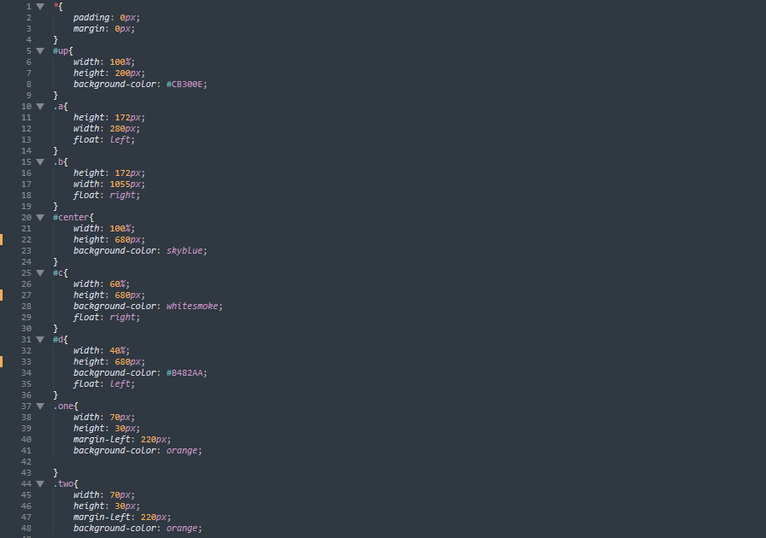

**A LOOK OVER JS CODING:-**

